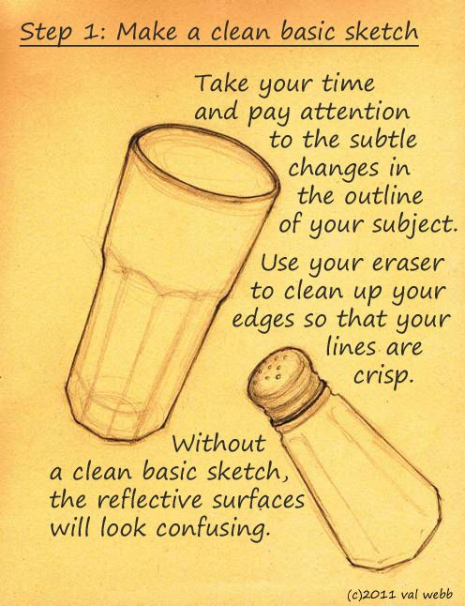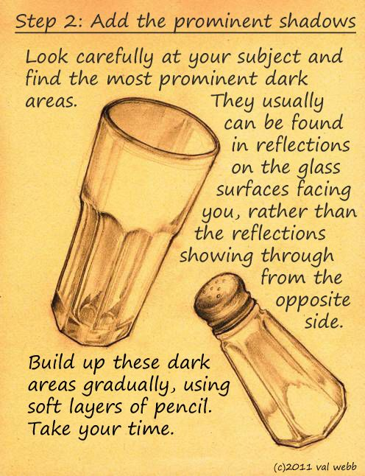
STEP #1 STEP #2
STEPS #3 & #4 are at end of this project sheet! Please follow the steps in order and one day at a time.
Project #2 – Transparency Sketchbook Assignment – 100 pts (Project to follow )
Due Date: March 27th at 12:00 Noon
Materials Needed: 9” x 12” sketchbook drawing paper, Your Graphite pencils, White Prismacolor, and color drawing paper- optional.
Description:
Find a glass object with interesting edges similar to the salt shaker/glass in the instructions above. The more details the object has the easier to develop the image when drawing it – and the drawing will be more interesting as well. A simple vase will not give you the same results.
Your drawing image should be a minimum of 9” x 5”.
To Be Successful - Please take your time by drawing STEP #1 – Monday, Step #2 – Tuesday, etc. This will help you pace yourself in completing the drawing and not rushing it.
ANSWER THE FOLLOWING QUESTIONS:
Meaning & Creative Thinking Assignment (Thumbnail Sketches) – 100 points:
Submit photo of your object and photograph each step each day labeled with the number of that step – 25 points each.
Showing your progress.
Photograph each day and submit for grade a total grade of 100 points, 25 pts for each step.

Connections: Describe your use of shading pencils – laying in of varying values & white prisma.
Assessment & Reflection – Describe what you like best about your drawing & share what you might do differently.
Project Directions/Rubric ( 20pts each):
A -Composition – Arrangement on the page.
B – Sketch the object lightly filling the 9” x 12” format in your sketchbook, image should be 9” x 5”.
C – Light sketching in of the image and the areas of subtle shading.
D – Using your shading pencils and white prismacolor, develop the 3-deminsionality of your object. Use your knowledge of 3-d shading of forms to complete.
E – Craftsmanship – Neat/ Clean

