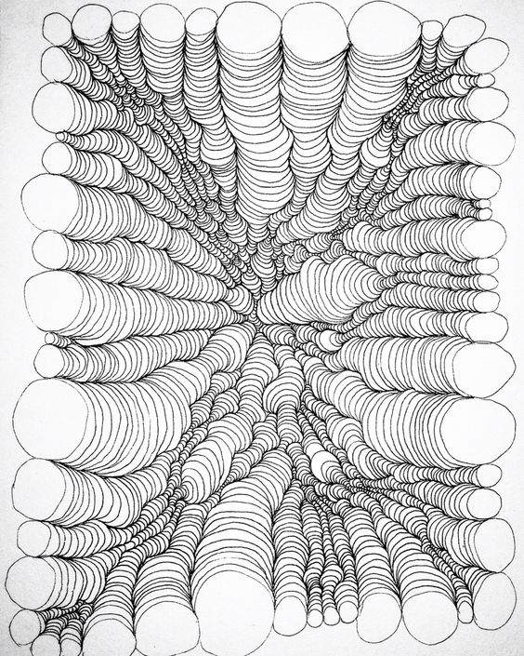
Project #2 – Optical Illusion Perspective Project – 100 pts
Due Date: March 27th at 12:00 Noon
STEP #1 STEP #2
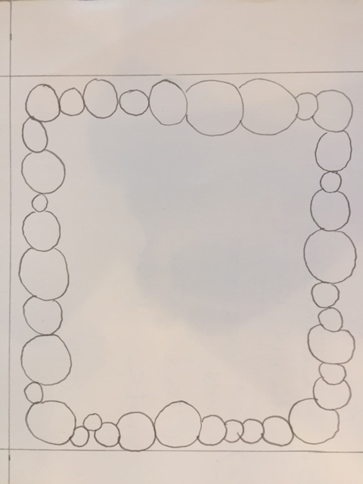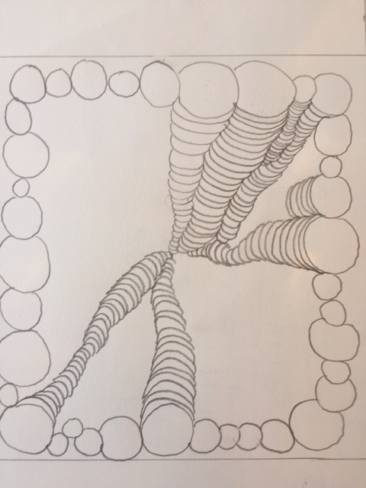
Materials Needed: Pencil, 8”x 10” sheet of paper or 9” x 12” drawing paper, black fine tip marker, color markers.
Description: Draw with pencil circles around the edge of your paper. Place a center mark on your paper to determine the direction of your progression when drawing next step. Then begin to draw partial circles around each of the previous working your way to the center mark of your paper. Each of these should look like columns of disks stacked atop each other and appearing to go back in space as you draw each circle smaller when “building your columns”.
Challenge: color the “columns” of circles to show them extending into space and/or to appear 3-d.
How would you do that?
Confused? Stay tuned for examples which I will post soon.
Meaning & Creative Thinking Assignment– 100 points:
Once you have completed the pencil layout, take a photo to Submit the drawing for a grade. Sign your name first.

Project Directions/Rubric ( 25 pts each): PHOTOGRAPH FINAL IMAGE & SUBMIT, with your name signed.
A – Line Drawing of above image. Should Fill the 9” x 12” format.
B – Creativity – developing the “columns” organically large to small. Look at the columns in the example that grow small then large then small again. Try it.
C – Pay attention to placement of circles to carefully end at the center of your paper.
D - Outline the lines neatly with sharpie OR color to create the 3-d effect.
E – Craftsmanship – Neat/ Clean, no smudges or gaps in coloring.
Submit Final Project complete with Shading/Coloring for 3-d – 100 points:
Once you have completed the pencil layout, take a photo to Submit the drawing for a grade. Sign your name first.

Submit Below Your 2 Responses to the following, ( 100 pts each):
Connections:
Describe in a sentence how you met the challenge of creating the feeling of 3-d space on your 2-d sheet of paper.

Assessment & Reflection:
What did you learn from completing this project with color or shading of the “columns”?
Share with me what you enjoyed about this project. What would you like as a new project? What supplies do you have at home that we can create some unique art?

