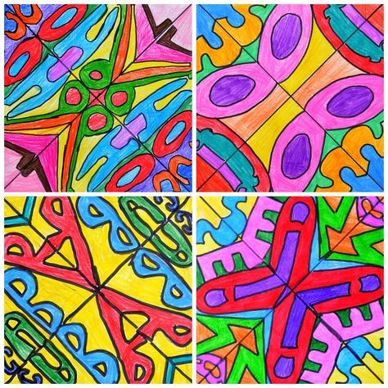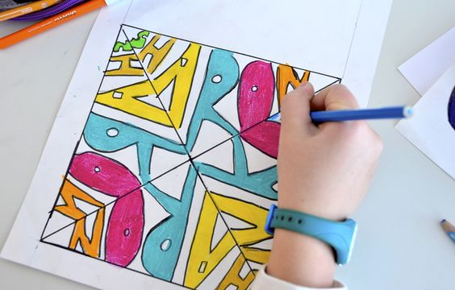
Project #1 – Radial Design Name Project – 100 pts
Due Date: March 20th at 12:00 Noon
Materials Needed: Pencil, 9”x 9” draw paper, black fine tip marker or ball point pen, color markers.
Description: Fold your 9” x 9” square paper diagonally, creasing from opposite corners, as shown below. Then, with a pencil, draw your name using “bubble letters” or shapes of letters to fill one quadrant of the paper. Now copy the image to each of the 3 remaining quadrants by folding your paper to copy from previous quadrant to develop a radial design. Radial Design is based on all elements radiating from the central axis. In other words, each way you turn the design it will look the same.
Meaning & Creative Thinking Assignment– 100 points:
Once you have completed the pencil layout, take a photo to Submit the drawing for a grade. Sign your name first.
Requirement is to draw the layout as close to the scale above, filling your 9” x 9” sketchbook paper.

Project Directions/Rubric ( 25 pts each): PHOTOGRAPH FINAL IMAGE & SUBMIT, with your name signed.
A – Line Drawing of above image. Should Fill the 9” x 9” format to scale.
B – Color neatly the letters of your name and the background with a contrasting color.
C – Pay attention to placement of colors to create Contrast – Light & Dark Areas.
D - Outline the letters neatly with sharpie.
E – Craftsmanship – Neat/ Clean, no smudges or gaps in coloring.
Submit Below Your 2 Responses to the following, ( 100 pts each):
Connections:
Describe in a sentence how you used ink pen/ ultrafine sharpie to develop Contrast in your drawing?

Assessment & Reflection:
What did you learn from using the grid method to layout the image to scale?

