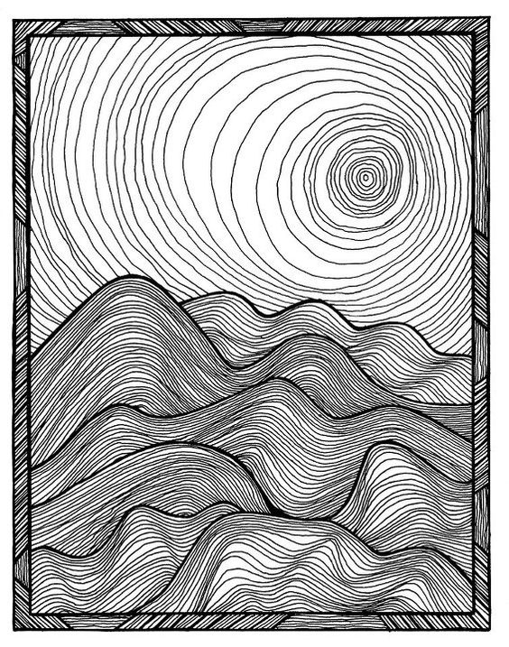
Project #1 – Line Drawing Project – 100 pts
Due Date: March 20th at 12:00 Noon
Materials Needed: Pencil, 9” x 12” draw paper, black fine tip marker or ball point pen.
Description: Using a pencil, draw the layout focusing on the dark outlines and where they enter and exit the format. For Example, use the grid method to assist in layout when drawing the image as closely to the image above as possible in pencil, save the continuous lines within for later. Fill concentric lines with ink pen paying attention to the value changes from light to dark and how these value changes are created.
Meaning & Creative Thinking Assignment– 100 points:
Once you have completed the pencil layout, take a photo to Submit the drawing for a grade.
Requirement is to draw the layout as close to the scale above, filling your 9” x 12” sketchbook paper.

Project Directions/Rubric ( 25 pts each): PHOTOGRAPH FINAL IMAGE & SUBMIT, with your name signed.
A – Line Drawing of above image. Should Fill the 9” x 12” format to scale.
B – Draw line with ultra fine tip sharpie or a ball point pen adding the detail concentric lines to fill mountains and then background with sun.
C – Pay attention to placement of lines to create Contrast – Light & Dark Areas.
D – Craftsmanship – Neat/ Clean Images and use of ink or color.
Submit Below Your Responses to the following, ( 100 pts each):

Connections:
Describe in a sentence how you used ink pen/ ultrafine sharpie to develop Contrast in your drawing?

Assessment & Reflection:
What did you learn from using the grid method to layout the image to scale?

