Project #5 – “Slice of Life Project”– 200 pts

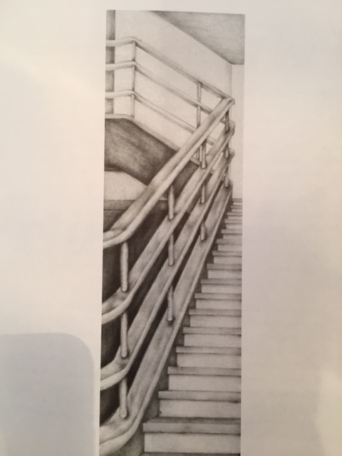
Due Date: April 27th at 12:00 Noon
Materials Needed: 9 x 12” sketchbook page paper, shading pencils.
Description: Working with an unconventional format challenges our habitual visual assumptions of art. One of many issues that arise for beginning artist is the tendency to make sure automatic decisions without challenging these assumed constants. In drawing, we assume our image will exist in a conventional rectilinear format – the golden rule. This 3:4 ratio approximates our visual field and seems somehow comfortable. We have become complacent to view art in the proportional relationship.
Cut out a viewfinder from an index card or sheet of paper with a 1:4 or 1:5 relationship, (i.e., opening would be 2”x 8” or 1”x 5”). Spend some time viewing your world through this window, using both the vertical layout and horizontal orientation. Does it seem as though you are peeking through a keyhole? Are you frustrated by the visual limitations? How could a figure or a portrait be interpreted through this window?
Try isolating a subject so that it becomes purely formal when viewed in such an extremely elongated format – where abstract dominates the referenced image of the subject. Consider images that exhibit vast spatial extremes – an interior and part of a window with a distant view, for example. Also, consider the eye level you select, high or down low.
Directions: Once you have chosen a subject/view, divide your sketchbook page into thirds in a landscape layout. Your format should measure – 3”wide x 12” long. As you draw the image captured in your viewfinder, be sure to sketch the layout just as you view it. Send me a photo once the sketch is complete for 100 points.
Project: Using your shading pencils, shade in your drawing with a full range of values. Suggestion: Try using your phone to capture a photo of the view through the viewfinder, using a filter, change the photo to black and white. This will make it much easier to draw the many values.
Project Directions/Rubric ( 25 pts each):
Meaning & Creative Thinking Assignment– 100 points:
Once you have completed your sketched compositional layout, share a photo of the image with me for 100 pts?
A – Image size – 3” x 12” with accurately drawn from your photo.
B – Creativity - Image drawn is recognizable and clearly a slice of the subject.
C – Contrast/ Values – clear use of 5-6 values in graphite creating great contrast.
D – Craftsmanship – Neat/ Clean Construction & Art Design.
E – Compelte the Assessment & Reflection Questions
Final Project Assignment– 100 points:
Submit a photo of your final artwork with the spiral of your sketchbook or with a ruler included for reference of size.

Submit Below Your Responses to the following, ( 100 pts each):
Connections:
Describe your difficulty in creating a viewfinder, finding a “Slice of Life” image, and copying the image to the 3”x12” format?

Assessment & Reflection:
As you view your final drawing, describe what you like about your artwork and what you would improve knowing what you know now?

