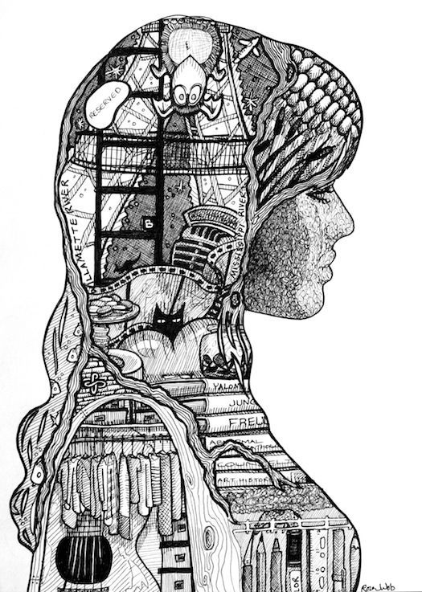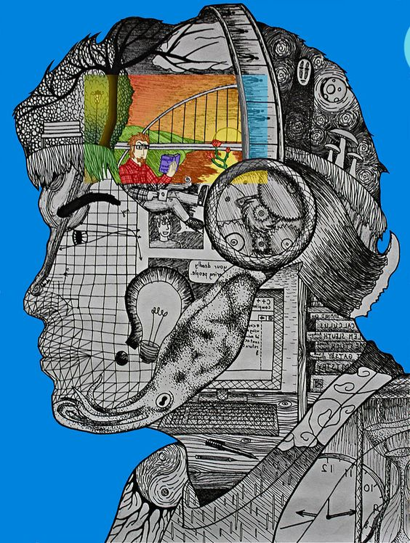
Project #1 – Self Portrait Silhouette Project – 100 pts
Due Date: March 20th at 12:00 Noon
Materials Needed: Pencil, 9” x 12” draw paper, black fine tip marker or ball point pen, color pencils/markers, optional.
Description: Have a friend draw a silhouette of you on a 9”x12” drawing paper. Then brainstorm a list of all the things that define you – Your visual self-portrait! What are your favorite things – family activities, what defined you as a kid, now, and your future. Where you hope to go to college or your future career? Using this list, you will then draw your self- portrait inside filling it with things that best describe you .
Meaning & Creative Thinking Assignment– 100 points:
Begin with a silhouette of yourself. Set up a darkroom with one light source, attach drawing paper to opposite wall, have a friend outline your silhouette/shadow onto the paper. The drawing must be accurately to scale and include your facial features. Draw in Hair, Eye, and Ear if you have short hair. Take photo to Submit the drawing and brainstorm list (20 items) for a grade.

Project Directions/Rubric ( 25 pts each):
A – Line Drawing of Your Silhouette - Should Fill the 9” x 12” format.
B – Creativity – fill interior of silhouette with pencil drawn images that describe you.
C – Ink drawing and or color of filled images creating Contrast of light and dark, refer to examples above.
D – Craftsmanship – Neat/ Clean Images and use of ink or color.
Submit Below Your Responses to the following, ( 100 pts each):

Connections:
Describe in a sentence how you used ink and/or color to develop Contrast in your drawing?

Assessment & Reflection:
What did you learn about yourself when creating the brainstorm list for this project?

