…I 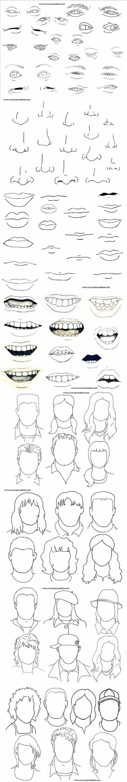

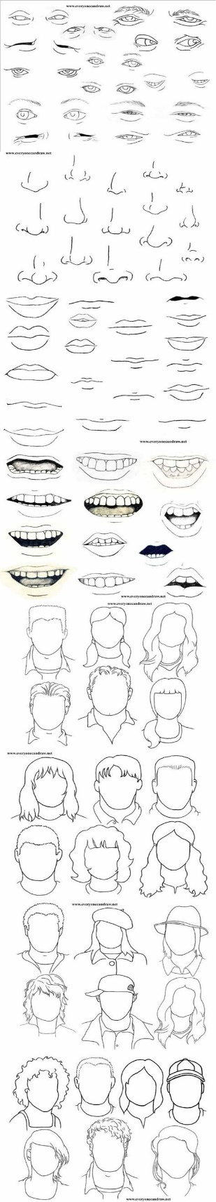

4/13 Assignment:

Take some time in your sketchbook to practice some of the eyes, noses, mouths in this handout. Then try creating 3 completely different characters using the faces and hair outlines found below.

Note: This is a large file so enlarge on your computer screen and then print.

Submit your three drawings on one sketchbook page to TEAMS, 8th grade.

Remember to follow the rules for portrait drawing layout we reviewed in class. Need a refresher? See below.

