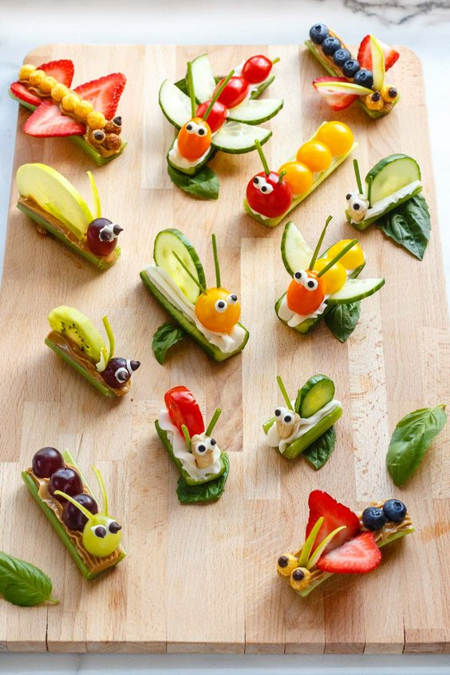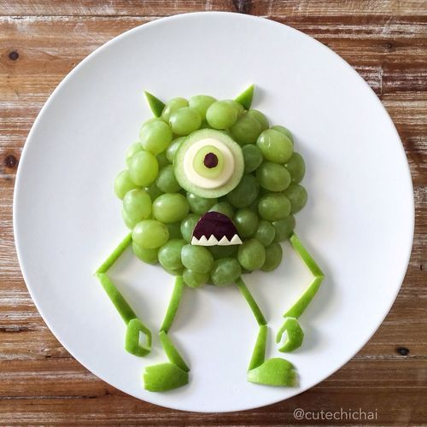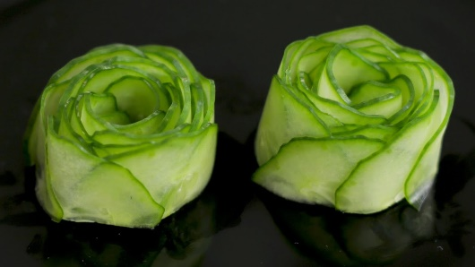

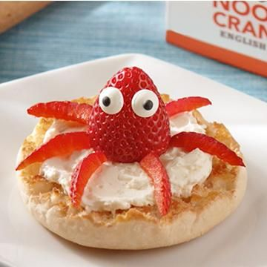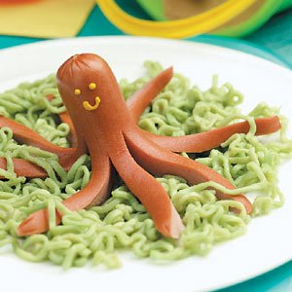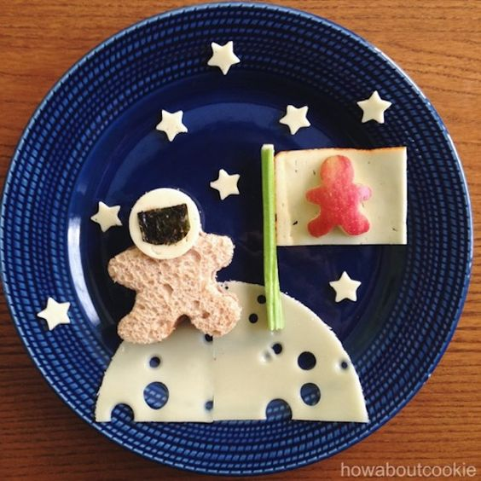
Project #3 – Food Art Display Project – 100 pts
Due Date: April 3rd at 12:00 Noon
Materials Needed: food ingredients to arrange your plate display
Description: Find an interesting idea and creative way to display your food art from researching Pinterest – Food Art. You will take a photo of your display and submit it for your assignment. I have provided photos for examples of how best to display and photograph your creations. Have FUN! BE CREATIVE!
Meaning & Creative Thinking Assignment– 100 points:
Question: Share some of the interesting food art you discovered when doing your research? I know you may have been limited on what you could create but if the sky is the limit what creation would you have considered for your project?

Rubric ( 25 pts each): PHOTOGRAPH FINAL IMAGE & SUBMIT in TEAMS.
A – Do your research, Find a creative idea or create your own design – it will be obvious you did your research.
B – Arrangement of your food art on the plate – This is a form of art too, the plate like your drawings must be composed.
C – Photography Lighting is important – Take practice photos to determine best lighting arrangement
D – Framing/Cropping Your Photo to display only your plate of food art – take several angle shots to get best photo then Submit your best photo in TEAMS.
E – Craftsmanship – Neat/ Clean Plate Presentation
Submit Below Your 2 Responses to the following, ( 100 pts each):
Connections:
Describe some issues you came across in preparing your food art.

Assessment & Reflection:
Describe some issues you came across in preparing your food art “display” when photographing? How did you overcome those obstacles and what might you do differently next time?

