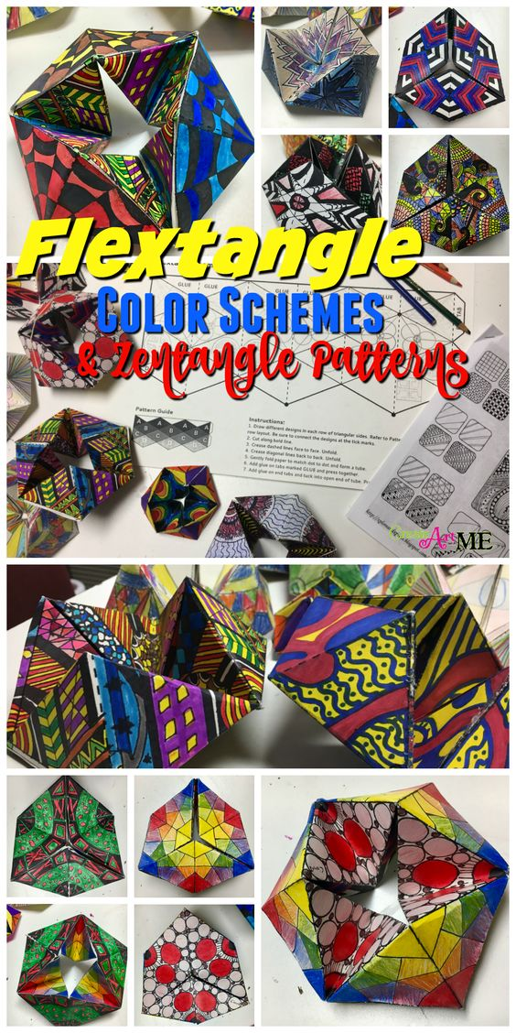
Project #3 – Hexaflexagon Project– 100 pts Hexaflexagon – The Ultimate Fidget!
Due Date: April 3rd at 12:00 Noon
Materials Needed: 8” x 10” sheet of printer paper, markers or color pencils.
Description: Follow the video link to view how to fold and build the hexaflexagon. Go slow – it is a process that requires precision when measuring and folding to insure your hexaflexagon will bend & flex when finished.
Once complete – Take time to develop a design on each side and color it in. Zentangle is a great for design ideas using an ink pen. There are 6 sides to the hexaflexagon so keep flexing to find all 6 sides. You can look up Vi Hart youtube videos as she started the whole craze a few years ago!
Meaning & Creative Thinking Assignment– 100 points:
Once you have completed your project, share with me a creative idea on how you could create a newer design using the hexaflexagon design as a springboard for your new idea?
Project Directions/Rubric ( 25 pts each):
A – Folding of Hexaflexagon, Accurate.
B – Creativity Designs on each side of the Hexaflexagon, Preferably color.
C – Submit 2 photos of completed work from different angles for credit – ZOOM in & place on a blank space for contrast.
D – Craftsmanship – Neat/ Clean Construction & Art Design.
Final Project Assignment– 100 points:
Submit 2 photographic views of your Hexaflexagon design.

Submit Below Your Responses to the following, ( 100 pts each):
Connections:
Describe your challenges folding & building your Hexaflexagon? How did you overcome these challenges? How many sides does your hexaflexagon have?

Assessment & Reflection:
Who first discovered the Flexagon or the Triflexagon? How old is the Flexagon?

