Shading Unit – 2 weeks
Students will complete the following in their sketchbooks using the various shading pencils in their purchased kit: shading a cone, cylinder, cube and sphere with a shadow.
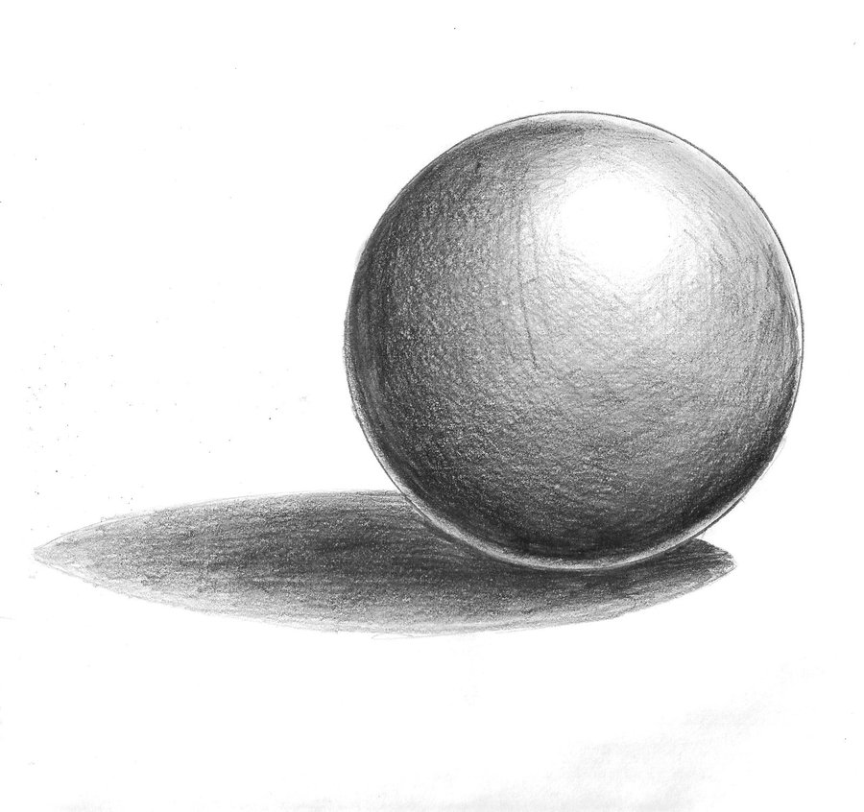

Techniques & Vocabulary taught: various line weights, cast shadow, core shadow, highlight, light source, value, tint, shade, blending (using a kneaded eraser), and creating 5 values with each shading pencil.

Standards to be met:
Element: VA7PR1.d
Develops a variety of skills in drawing (e.g., observational, illusion of form, tonal rendering, perspective) to convey meaning and idea.
Element: VA7MC3.c
Recognizes and evaluates how artists choose and use materials, visual elements,/principles, styles, techniques and tools to shape and communicate meaning.

Project: Students will complete a Still life of 5-7 objects utilizing 70% + of Positive Space, include 5 -7 values, cast & core shadows, and blend. Students will draw from observation.
Project due 2/19th at the end of class.

