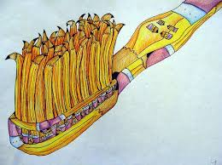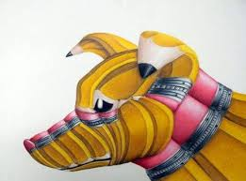
Project #1 – Yellow # 2 Pencil Transformation Project – 100 pts
Due Date: March 20th at 12:00 Noon
Materials Needed: No. 2 Pencil for reference, 9” x 12” draw paper, Watercolors or Prismacolor pencils, black fine tip marker (optional).
Description:
Grab a # 2 yellow pencil – study it – think about how the pencil could be bent, enlarged, stretched, or even crushed to transform the look of any object as seen above. There are many examples on the internet so look around for ideas. Your goal is to NOT copy an image but to create your own.
Meaning & Creative Thinking Assignment (Thumbnail Sketches) – 100 points:
Begin with thumbnail sketches, fill a 9”x12” page in your sketchbook with 4 thumbnail sketches approx.. 4”x 5” ea, working out ideas of what you could possibly use as your final project. Choose 2-3 images of insects, sports, or musical instruments, etc to use as your image to fill with your pencil drawings. I want to see your brainstorming of ideas. You are welcome to copy one image from internet to get the creative juices going. Photograph and submit for grade.

Answer the following questions -
Connections:
Explain how you developed your idea for your project?
Assessment & Reflection –
Reflecting on your process of developing your image, what did you find most difficult & were you pleased with your use of composition and Positive/Negative Space?

Project Directions/Rubric ( 20pts each):
A -Choose your thumbnail image to enlarge – Compositional Arrangement, 70% Positive/30% Negative Space. Refer to images above.
B – Sketch the object lightly filling the 9” x 12” format in your sketchbook, composition always counts.
C – Now begin to draw the outline of pencils to bend and fill the image – Creativity Counts!
D – Using Prismacolor or Watercolors, develop the 3-deminsionality of each pencil. Use your knowledge of 3-d shading of cylinders to complete.
E – Craftsmanship – Neat/ Clean & You must maintain the color of the traditional pencil: yellow, with black lettering and a pink eraser, etc.

