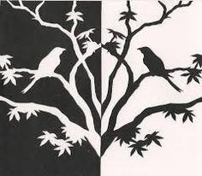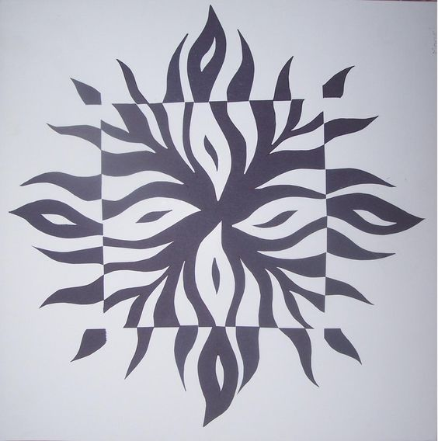
Project #1 – Symmetrical Balance Project– 100 pts
Due Date: March 27th at 12:00 Noon
Materials Needed: Pencil, 9” x 12” draw paper – your sketchbook page, black or color marker.
Description: Fold your paper in half – Hamburger style. Draw the design you see or you may choose a design to draw on ½ of the paper. You will then use the light at your window to trace the mirror image to the other half of your sketchbook page. When finished, you should have a mirror image which fills your 9” x 12” page. Finally, fill interior of image on ½ of page and fill the background in black/color marker.
Meaning & Creative Thinking Assignment– 100 points:
Submit a photo of your pencil drawing of the mirror image you traced at the window.
Project Directions/Rubric ( 25 pts each):
A – Line Drawing of Your Symmetrical Balance - Should Fill the 9” x 12” format.
B – Creativity – Your ability to trace this image or draw a design of your choice showing your personal challenge.
C – Black/color marker to filled images creating Contrast.
D – Craftsmanship – Neat/ Clean Images and use of marker.
Submit Below Your Responses to the following, ( 100 pts each):
Connections:
Describe your challenges in drawing the image shown or the image of your choice? What where the difficulties found when developing this project?

Assessment & Reflection:
Describe the differences of a Symmetrical Balance, Assymetrical Balance, and Radial Balance?

