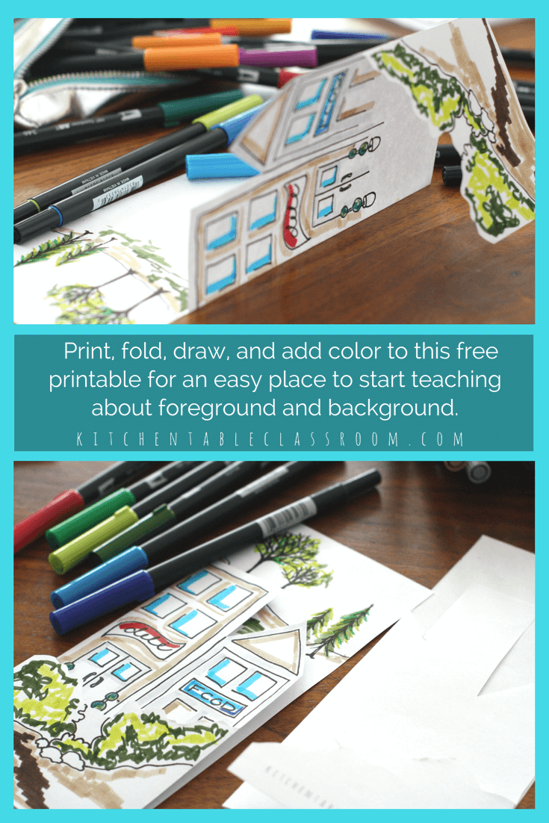

credited - kitchentableclassroom

Landscape Divided…..

Foreground, Mid Ground and background are concepts that apply to Most 2-D projects. You will find them most often in Landscapes and still lifes but the concepts are also created in abstract art by using overlapping, etc. The foreground, midground, and background divide the landscape, for example, into different Geometric planes that the artist uses to create a sense of depth.

FOREGround

the foreground is typically closer to the bottom of the composition, although that may not always be the case. Because this part of the scene is closest to the viewer the objects will appear larger.

background

The background of a scene is the furthest away. it provides context to the scene – where it may be taking place. Because items in the bakcground are meant to appear farther away, they are much smaller in size, duller in color and contain less detail than objects in the foreground.

Finding the Midground ……

The middle ground lies somewhere between the background and the foreground, easy right?

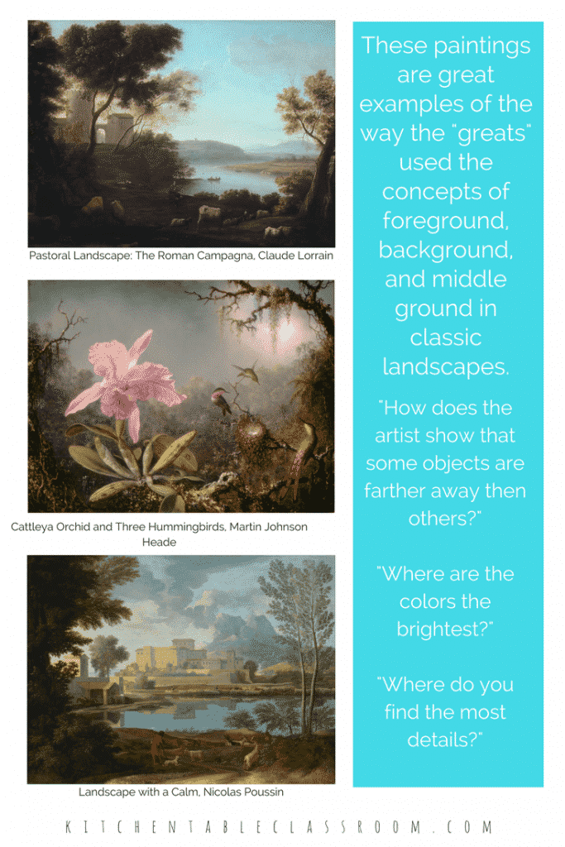

Review the artwork above and answer these questions:

WHERE ARE COLORS THE BRIGHTEST?

WHERE ARE THE MOST DETAILS EVIDENT IN THE PAINTINGS?

DO YOU NOTICE ANYTHING SPECIAL ABOUT THE WAY SIZES OF OBJECTS RELATE TO EACH OTHER?

IN THE CENTER PAINTING “CATTLEYA ORCHID” DO YOU THINK THE ORCHID IS REALLY BIGGER THAN THE HUMMINGBIRD? IS IT BIGGER THAN THE TREE?

BASIC TECHNIQUES TO CREATE SPACE WITHIN A WORK OF ART…

OVERLAP- SHAPES IN THE DISTANCE WILL BE OVERLAPPED BY SHAPES THAT ARE CLOSER.

SHADING- ADDING SHADING AND SHADOWS TO 2-d SHAPES CAN MAKE THEM APPEAR 3-d.

PLACEMENT- OBJECTS THAT ARE FARTHER AWAY ARE PLACED CLOSER TO THE HORIZON LINE.

SIZE- OBJECTS THAT ARE FAR AWAY APPEAR SMALLER. OBJECTS THAT ARE CLOSER TO THE VIEWER APPEAR LARGER.

VALUE AND FOCUS- OBJECTS THAT ARE FAR AWAY APPEAR LIGHTER IN COLOR AND LESS CLEAR THAN OBJECTS THAT ARE CLOSEr.

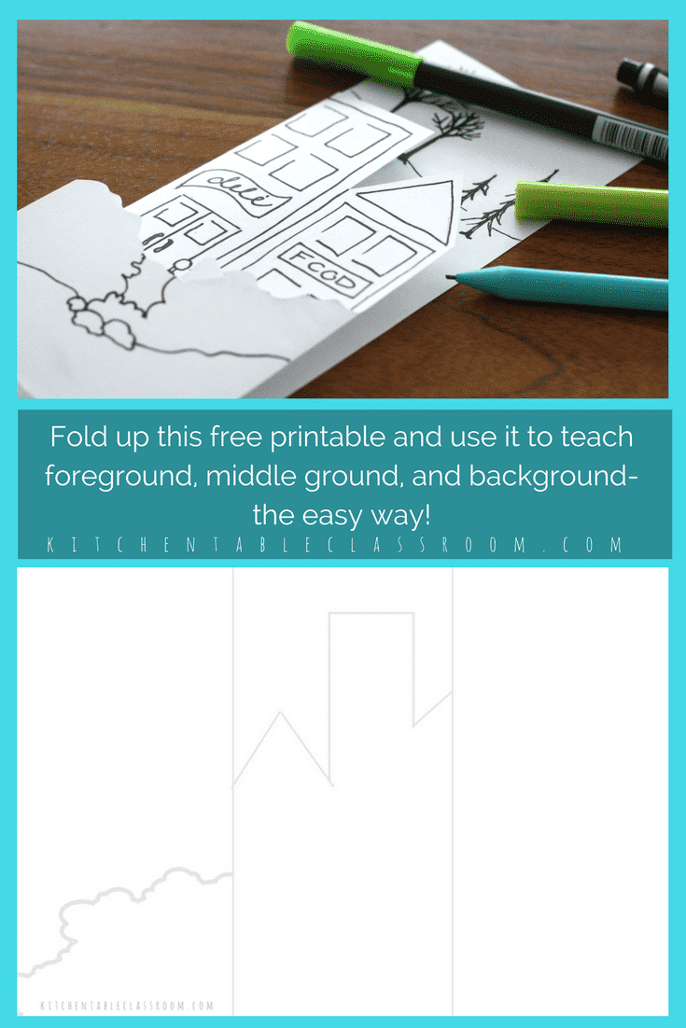
- Folding your paper :
Fold your paper neatly into thirds, accordian style using the vertical lines.
It is important not to begin drawing until you have folded. In some places you will be drawing on the back of the paper when it is flat. This foreground middleground background image has a super simple skyline. Sketch into each third the images you see below or create your own images for foreground, background, and midground.
Come up with unique solutions to fill your space.
Supplies – use pencils, markers, colored pencils, whatever floats your boat! Another quick and easy option is to paint with watercolors or you can use color markers with water for a watercolor look – do practice this on scrap paper first.

