Prismacolor Project Practice Sheet:
100 points
In your sketchbook, complete the following practice techniques ( chisel, blunt, etc) & then develop the drawings of cube, sphere and cone, approx.. size – 2.5 inches each.
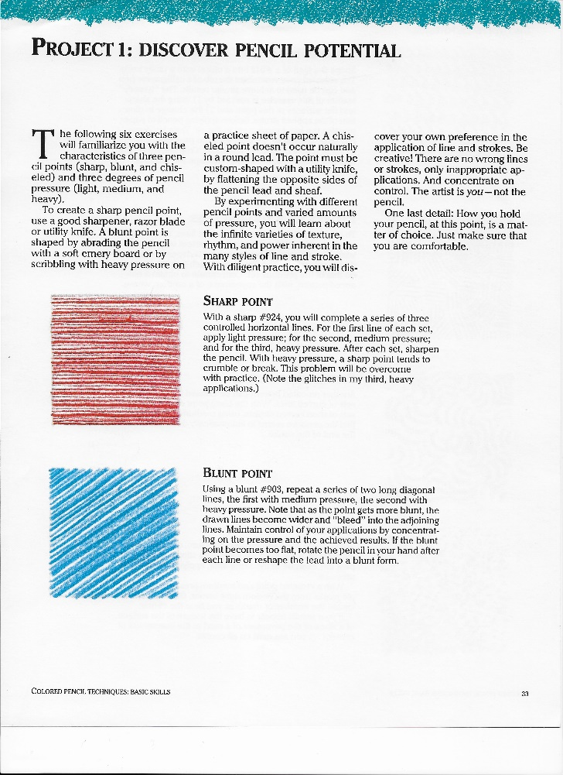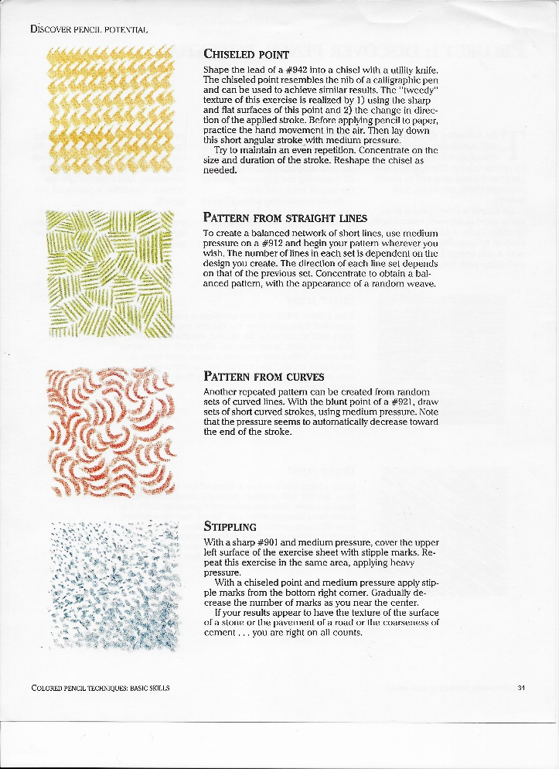

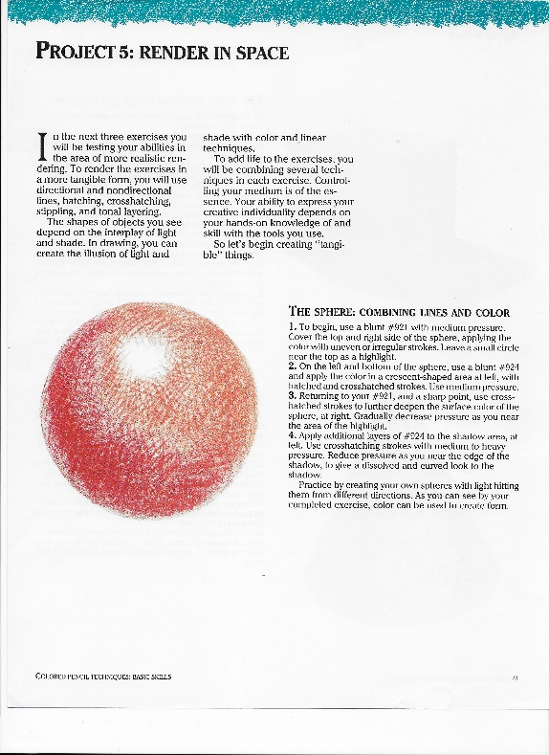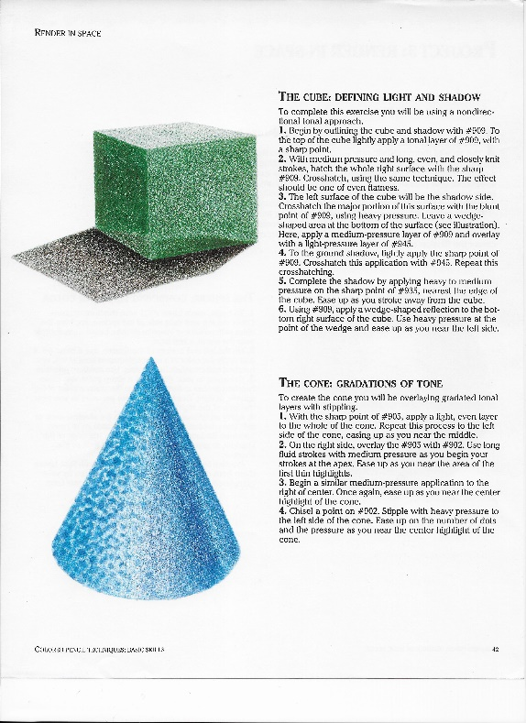

Prismacolor Toy Top Project:
200 points
Follow directions on use of pencils and layering for each step. If you have the 12 basic pack of Prisma’s then it may be difficult to complete but it is not impossible, just substitute the closest color.
NOTE: I will add a chart of pencil colors & numbers to the resources in this assignment.
#1 – Trace the image – I know it is very light, print it out then outline it with sharpie then trace. You could color the printout but you will not get the richness of colors if not using drawing paper from your sketchbook as your support.
#2 – Once traced on drawing paper, begin with Step #1 in the images doing exactly what is described in layering of colors following each step through to Step #6.
You will be amazed at your final drawing when finished if you are patient and follow directions.
I can not wait to see your final drawing!

Packet is Attached Below.
